**2 PROBLEM DEFINITION & DESIGN THINKING**

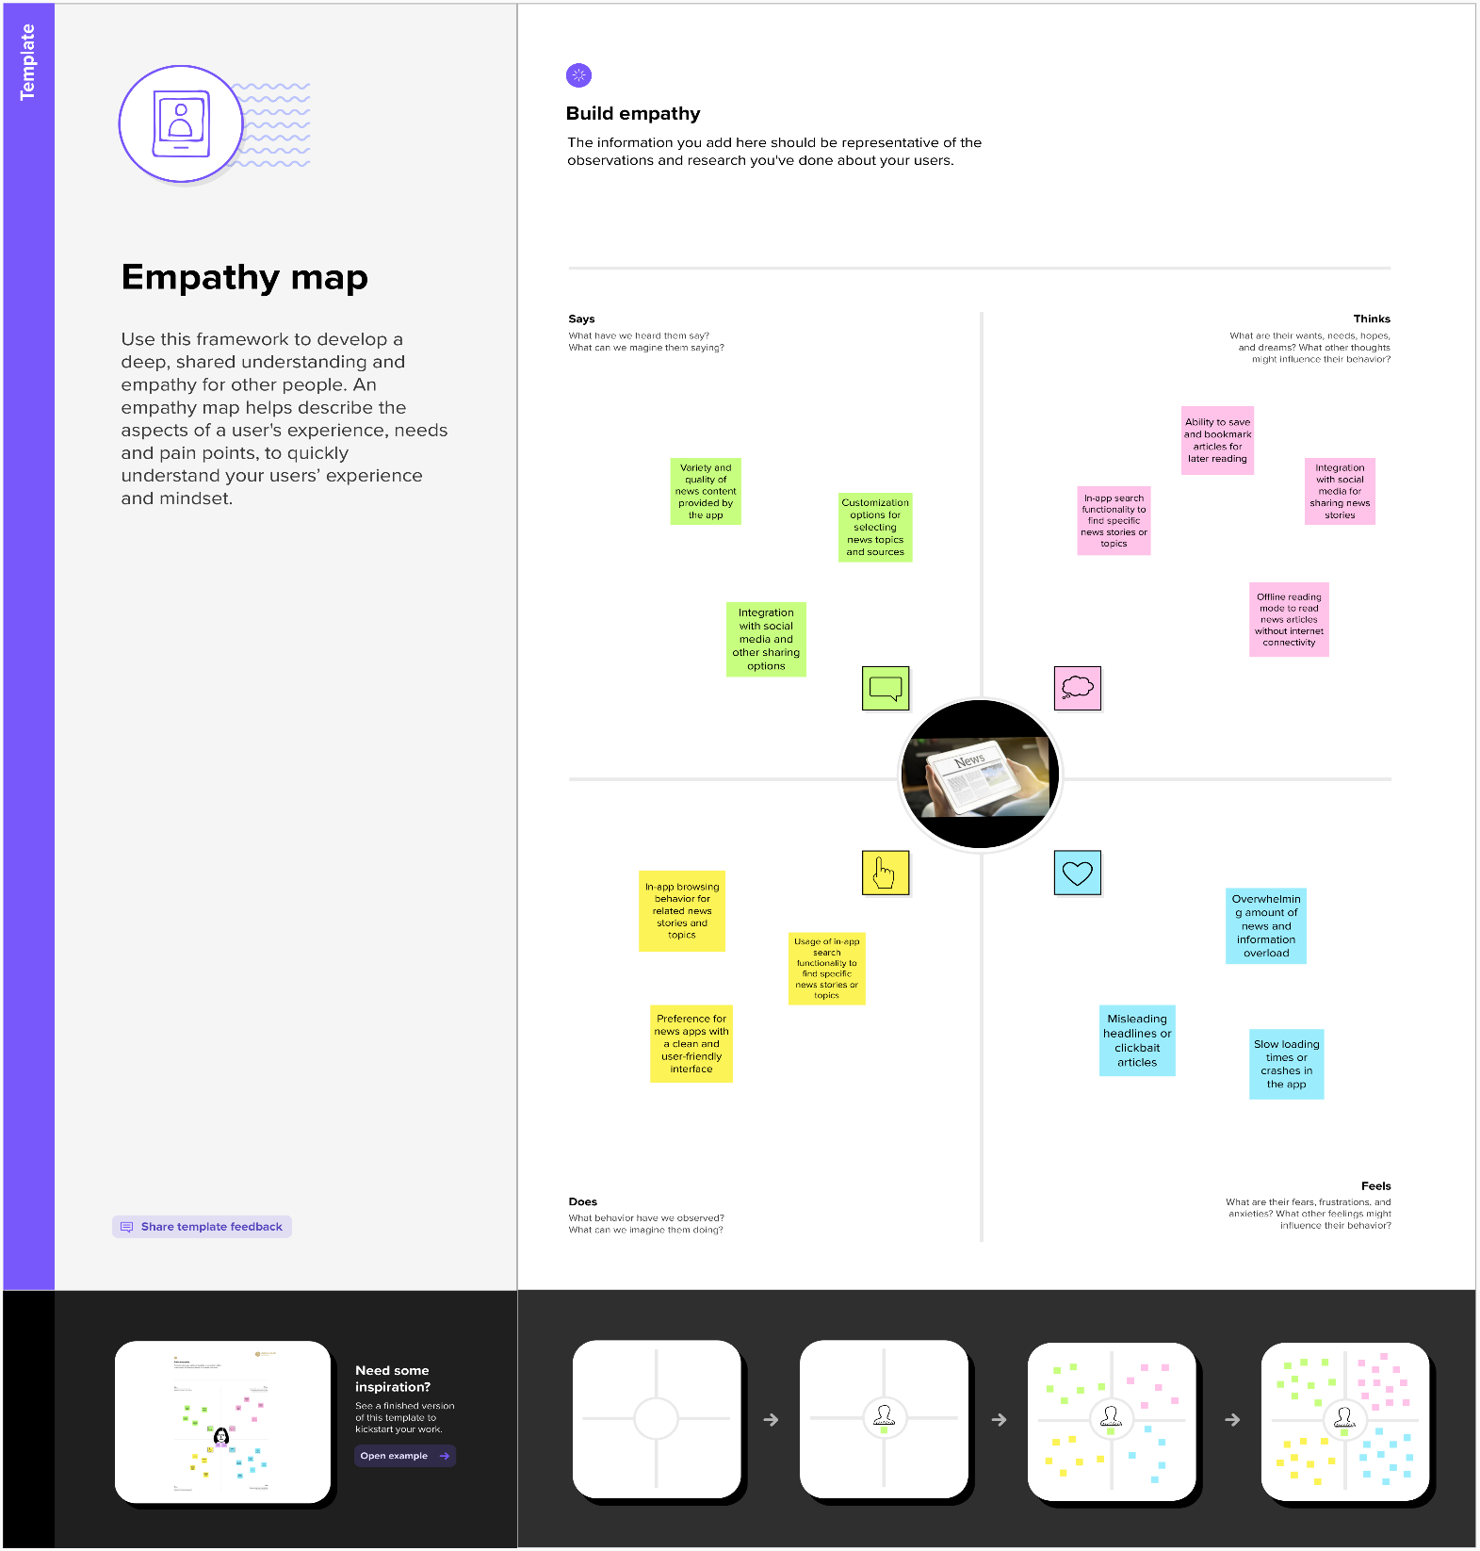**2.1 Empathy Map:**

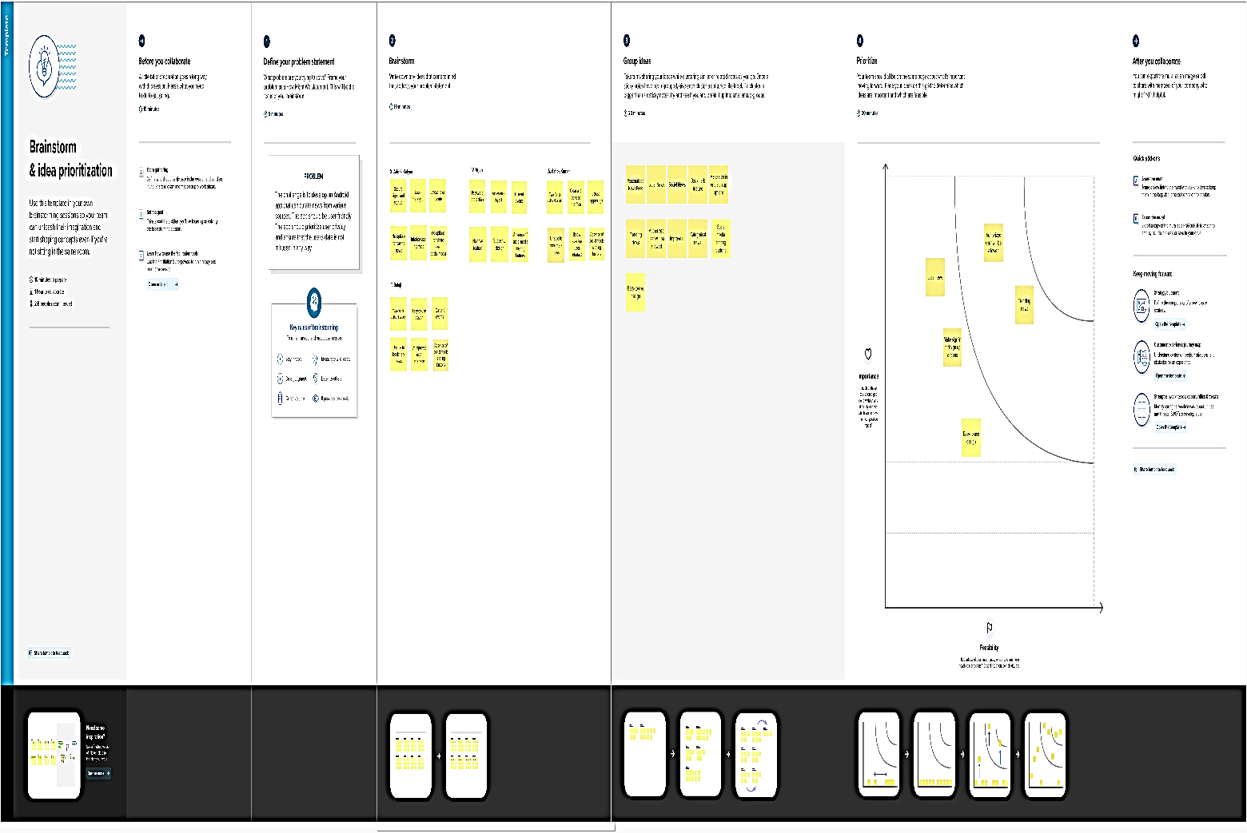**2.2 Ideation & Brainstorming Map:**